TO RECEIVE A PRICE QUOTE, PLEASE COPMLETE THIS FORM AND RETURN TO PANINI:
Panini S.r.l., Attn: Sales Department |  | TEL: | +39 0536.94.07.07
Via Dino Taruffi, 70 |  | FAX. | +39 0536.94.37.05
41053 Maranello MO Italia |  | E-MAIL: | mailbox@op-panini.it

NAME: |  |  | DATE:
COMPANY: |  |  | TEL:
ADDRESS: |  |  | FAX:
 |  |  | E-MAIL:

MODEL
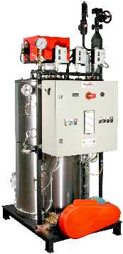 | 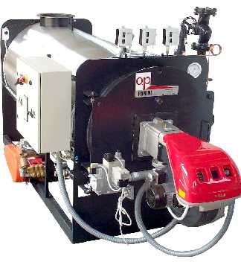 | 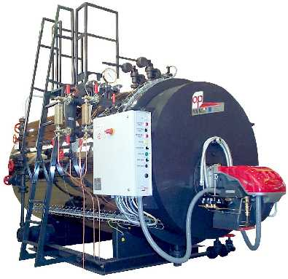 | 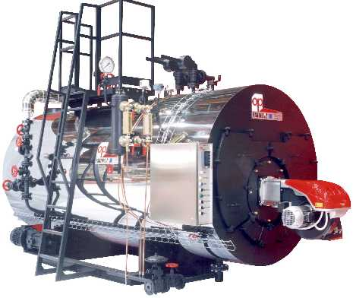 | 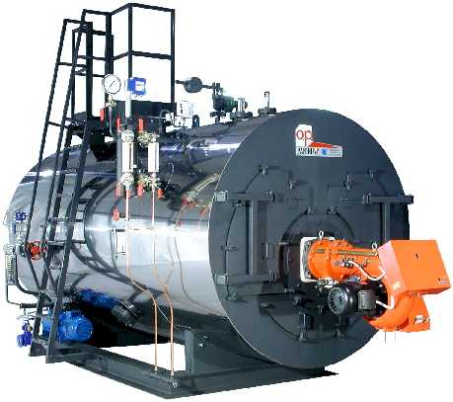
VAPORAPID–V | VAPORAPID–O | SPRINT | SPECIAL | ECOVAP
1,2 MPa | 1,2 MPa | 1,2 MPa | 1,2 o 1,5 MPa | 1,2 o 1,5 MPa
45–1000 Kg/h | 400–3000 Kg/h | 660–4000 Kg/h | 2400–4000 Kg/h | 4000–20.000 Kg/h

MODEL: |  |  | STEAM: |  | KG/H | PRESSURE: |  | MPa | N° BOILERS

BURNER: |  1-Stage  2-Stage  Modulating

FUEL: |  Methane Gas | GAS MAINS PRESSURE: |  | MBAR

 Light Oil (diesel)  Medium Oil 3-5 °E at 50°C  Heavy Oil >7°E at 50°C

ACCESSORIES (only for Sprint, Special and Ecovap models)
WATER LEVEL KIT: |  Min/Max   Constant | { | Min/Max uses the classic min and max probes to control the water pump. Constant maintains the same water level by regulating pneumatic valves.
PUMP KIT: |  Single   Double | { | The double pump allows repairing or substituting one pump while the boiler continues to function.
BLOWDOWN KIT: |  Manual   Automatic | { | Simple manually-actuated valve or automatic blowdown kit with pneumatic valve and electronic timer.
PRE-HEATER KIT: |  No   External   Integrated | { | Preheats the carburant air using excess exhaust heat, increasing the boiler yield. Note: the integrated pre-heater is available only for the Special and Ecovap models.
INJECTOR KIT: |  Yes   No | { | Safety device that continues water feed in case of a pump error. Suggested only where a backup feed mechanism is mandatory by law.
SALINITY KIT: |  Yes   No | { | Automatically drains the salty top water layer when high salt concentrations are measured.
O₂:ALARM KIT: |  Yes   No | { | Raises an alarm in case of a high stack O₂ count, indicating sub-optimal burner calibration.
O₂ CONTROL KIT: |  Yes   No | { | Automatically calibrates the fuel mixture to keep a constant O₂ count at the stack. Requires a special burner.

RESERVED FOR PANINI SALES DEPARTMENT
REC'D BY: |  | DATE REC'D: |  | REQUEST #:
SENT BY: |  | DATE SENT: |  | OFFER #:

SMOKE STACK
SMOKE STACK: |  None  Boiler-based stack  Ground-based stack with connector
CONSTRUCTION: |  Mild Steel  Stainless AISI 304  Stainless AISI 316
CLADDING: |  None  Aluminum  Stainless AISI 304
STACK HEIGHT: |  | METERS
CONNECTOR: |  | METERS | (only for ground-based stack)

FEED WATER TANK
The feed water tank provides positive head pressure to the pump and preheats the with condensate return.
TANK TYPE: |  None  Vertical  Horizontal  Select most adapted for boiler
CLADDING: |  None  Polyurethane  Aluminum  Stainless AISI 304
DEOXYGENIZER: |  Include optional thermophysical deoxygenizer module (only for horizontal tank)

WATER TREATMENT ACCESSORIES
 Water Filter | Removes from the water particulates and large impurities which foul the water-softener resins and the reverse osmosis membranes.
 Dosage Kit | Injects into the water chemical products which remove dissolved oxygen and CO₂.
 Water Softener | Converts calcium and magnesium salts (that cause scaling) into sodium salts (that don't cause scaling), but does not reduce the total salinity. Select between 2 types:   Single Column. Includes 1 resin tank with a timer which regenerates the resin at predetermined intervals (usually at the end of the workday) whether needed or not.   Double Column. Includes 2 resin tanks and advanced volumetric regeneration (the resins are regenerated only when a predetermined amount of water has passed).
 Reverse Osmosis | Removes all hardness ions and impurities, and the majority of dissolved salts, eliminating scaling and sludge buildup. Requires a water softener and the dosage kit.

FEED WATER CHARACTERISTICS
To select the size of the water treatment system, attach a chemical analysis of the feed water, or indicate the following water data. If no data are indicated, we will assume the values in parenthesis. Note: these default values are quite high and may lead to unnecessarily large water treatment systems in soft-water areas.
WATER HARDNESS: |  | °F | (45°F) | Note: 1°F = 10ppm = 0,585gpg
CONDENSATE RECOVERY: |  | % | (50%)
STANDARD WORKDAY: |  | HOURS | (8 HOURS)

ALTRE NOTE

